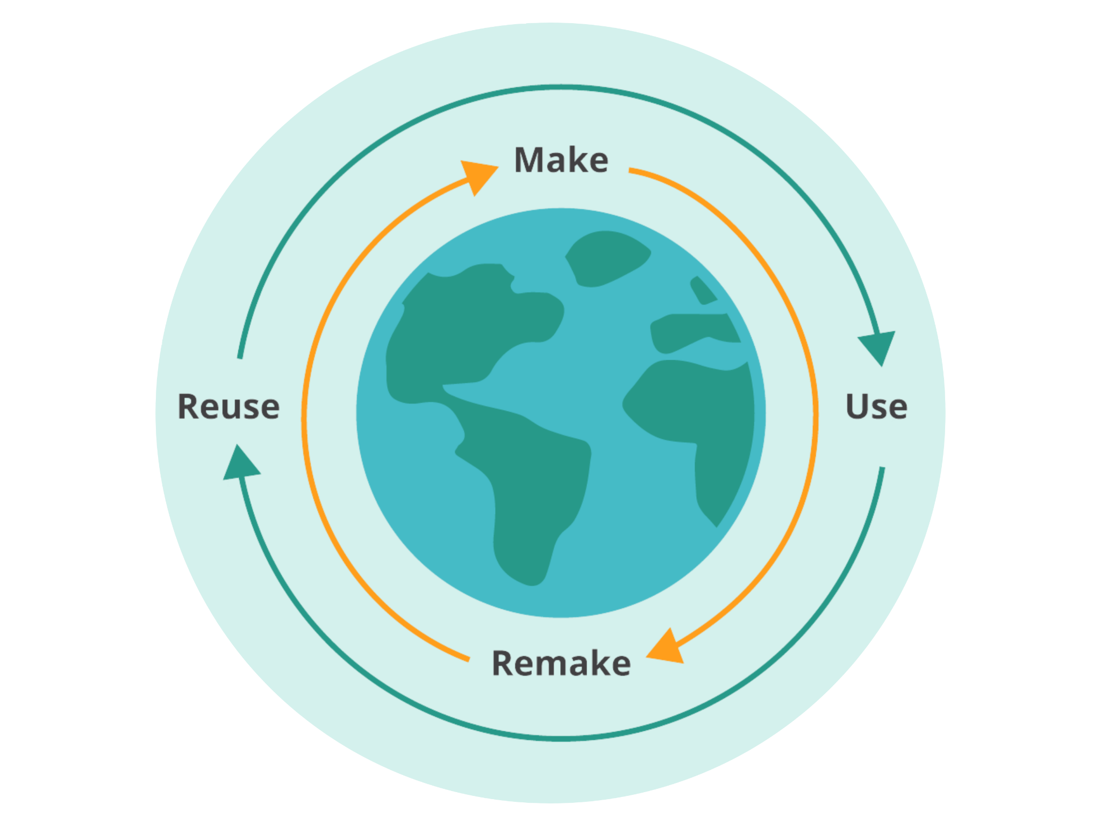

Eco 360 Challenge
2021 - 2022

The Eco 360 Program enables youth to imagine a world without waste by closing the loop of a product’s life cycle and creating a circular economy. Learners explore the origin of plastics, their use in our daily lives, how they end up in the environment as waste and how we can ensure that plastics are cycled back into the economy. This package contains everything you need to complete and submit an entry for the 2022 Eco 360 Challenge:

Challenge Instructions 1
Selection Criteria 3
Entry Form - A 4
Entry Form - B 5
Educator Feedback 6
GreenLearning Media Release Form 8

Complete the following entry form and upload it to the submission page here by Friday, May 20, 2022 at 11:59pm PST. Best of luck to you and your learners! If you have any questions or concerns at any time, please contact us at programs@greenlearning.ca or check out our Frequently Asked Questions page.

Challenge Instructions
The following outlines the instructions for completing and submitting an entry for the 2022 Eco 360 Challenge:
- In order to give your learners the necessary knowledge and skills to complete the challenge, we highly recommend completing a selection of the following learning activities:
Understanding Plastics
    - What Are Plastics?
    - Different Types of Plastics
    - Properties of Plastics
The Impact Of Plastics On The Environment
    - Sources of Plastic Waste in the Environment
    - Plastics in the Environment
    - Plastics in Our Oceans
The Circular Economy
    - What is a Circular Economy?
    - Circular Economy, Sustainability and Climate Action
    - Reimagining Economy Using Biomimicry
A Circular Economy For Plastics (Complete three activities)
    - Policy Action: Circular Economy for Plastics
    - Plastic Waste Management in Canada
    - Plastic Waste to Energy
    - Plastic Waste to Consumer Goods
Personal Plastic Consumption
    - What is Your Plastic Consumption Footprint?
- Develop your innovation plan:
Using the Innovation Plan Worksheet, develop a feasible and creative plan that incorporates a circular economic model to eliminate plastic waste from our environment.
- Create a fun and creative three-minute video pitching your innovation plan:
Be sure to use the Innovation Plan Worksheet as a guide on what to include in your video.
- Share your video pitch on social media, with your family and in your school community. Don’t forget to tag @GreenLearning on Twitter, Instagram and Facebook.
- Complete one Challenge Entry Form for your class and one Media Release Form per individual in any photos or videos you send in showing an individual’s face. Each class can submit up to 5 Innovation Plan Worksheets and corresponding Videos for judging. For more information please see the FAQ page.
- Submission checklist:
- Innovation Plan Worksheet;
- Video Pitch;
- Challenge Entry Form and;
- Media Release Form(s)
Please submit all materials and forms here by May 20, 2022 at 11:59pm PST.

Entries that meet the requirements outlined in the Eco 360 Challenge Rules and Regulations will be judged between May 24, 2022 and June 6, 2022. The first, second and third place submissions will be awarded cash prizes of $1,000, $500 and $250 respectively. Winners will be announced online on or around June 8th, 2022.

Selection Criteria
GreenLearning has recruited a panel of industry experts with experience and expertise on circular economic models and plastic waste to judge and provide feedback on challenge submissions. This panel of judges will be evaluating submissions based on the following selection criteria:
Criteria | Level 4 | Level 3 | Level 2 | Level 1
Innovation Plan: Ideas  Creativity and problem solving.  (10 points) | A strong solution is offered that is both logical and creative in tackling plastic waste. | A solution is offered that is logical or creative in tackling plastic waste. | A solution is offered that is somewhat logical or creative in tackling plastic waste. | The solution offered is not logical or creative intackling plastic waste.
Innovation Plan: Impact  Kilograms of plastic waste diverted.  (10 points) | The solution offered would result in a high amount of diverted plastic waste. | The solution offered would result in a moderate amount of diverted plastic waste. | The solution offered would result in a limited amount of diverted plastic waste. | The solution offered would result in little or no diverted plastic waste.
Video Pitch: Content  Communication and systems thinking.  (10 points) | All components of the innovation plan are highlighted throughout the video. | Most components of the innovation plan are highlighted throughout the video. | Some components of the innovation plan are highlighted throughout the video. | Few components of the innovation plan are highlighted throughout the video.
Video Pitch: Delivery  Creativity and communication.  (10 points) | Video is easy to follow, highly engaging, and creative in its delivery. | Video is mostly easy to follow, engaging, and creative in its delivery. | Video is somewhat easy to follow and has some creativity in its delivery. | Video is difficult to follow and somewhat creative or engaging in its delivery.
Entry Form: Sharing Your Learning  Communication and collaboration.  (10 points) | Learning was shared with different audiences on multiple occasions. | Learning was shared with different audiences or on multiple occasions. | Some learning was shared with an audience outside the submission group. | No learning was shared throughout this challenge.
Entry Form: Reflection Exit Question  Creativity and critical thinking.  (20 points) | Recommendations apply a strong circular economic model and are highly creative. | Recommendations apply a circular economic model and are creative. | Recommendations somewhat apply a circular economic model and are creative. | Recommendations do not include a circular economic model and lack creativity.

Entry Form - A
Please tell us about yourself and your class. If more than one educator or group leader was involved please complete this form based on who will be the main contact. This section is not scored.

Educator’s name:

Educator’s email address:

How would you, the educator, like to be referenced in the online showcase? (E.g. Ms. Frizzle)

School name:

School city:

School province:

Educator and school social media handles:

The number of learners participating:

Grade level(s):

Subject(s) or club name:

Entry Form - B
The following questions can be answered by an educator or learner, with the exception of question 3, which must be completed by a learner. This section is scored. Please see the Selection Criteria for details.

- What is the most creative or innovative component of your Innovation Plan?

- How did you share your learning with your community and how many people did you reach as a result? Please provide a breakdown of your reach. E.g. Social media, school newsletters or community consultations.

- Challenge Reflection Exit Question (to be completed by the class or a specific learner):
What are your main recommendations for Canada to move to a circular economy for plastics? This can be submitted in any media form (ie written, video, Google Slide presentation, song/rap)

Educator Feedback
GreenLearning is consistently looking for ways to improve our challenges and collect participant feedback. Please take a few moments to tell us about your experience by answering the questions below. This section is not scored.

- Are there any resources, strategies or tips that you would share with another educator looking to complete the Eco 360 Challenge with their learners?

- Why did you decide to participate in the Eco 360 Challenge?

- How did participating in this challenge benefit your learners’ understanding of a circular economy and plastic waste?

- How effective was this challenge in building youth understanding of a circular economy and plastic waste? Please highlight your selection.

Not effective 1 2 3 4 5 Very effective

- How effective was this challenge in building youth skills as 21st Century learners? Please highlight your selection.

Not effective 1 2 3 4 5 Very effective

- How effective was this challenge and GreenLearning's resources and lessons in improving your capacity to deliver learning about a circular economy and plastic waste? Please highlight your selection.

Not effective 1 2 3 4 5 Very effective

- How effective was this challenge and GreenLearning's resources and lessons in meeting your curriculum goals? Please highlight your selection.

Not effective 1 2 3 4 5 Very effective

- Is there anything else you would like to share with the GreenLearning team?

Please upload all relevant documents and media on the submission page here before May 20, 2022 at 11:59 PST to be eligible for one of the grand prizes of $1,000, $500, or $250.

GreenLearning Media Release Form

I am aware that my name or my picture or my voice may appear in a print advertisement or other promotional material or be shown on the internet on which my picture can be seen or my voice heard on a recording and I hereby grant permission to GreenLearning Canada Foundation to use my picture, voice, or name for these purposes.

I hereby authorize GreenLearning Canada Foundation to use and publish my name, statements and likeness without charge, for promotional purposes in publications, advertising, video, web, new media, and other formats.

I hereby release GreenLearning Canada Foundation, and its officers, employees, shareholders, and directors from any and all liability whatsoever, for now, and forever.

Full Name:

Signature:

Email:

Phone:

If under 18, parent name and signature is also required:

Name:

Signature:

Date:

